**Visvesvaraya Technological University**

**Belagavi - 590 018, Karnataka**



A Mini Project Report on

## “DENTAL CLINIC MANAGEMENT SYSTEM ”

#### Mini Project Report submitted in partial fulfillment of the requirement for the DBMS Laboratory with Mini Project [18CSL58]

## Bachelor of Engineering

**in**

**“Computer Science and Engineering”**

### Submitted by

**Manu S Salimath [1JT20CS046]**

**Murali G [1JT20CS048]**



## Department of Computer Science and Engineering

## Jyothy Institute of Technology

## Tataguni, Bengaluru-560082

**Jyothy Institute of Technology**

**Tataguni, Bengaluru-560082**

**Department of Computer Science and Engineering**



## CERTIFICATE

Certified that the mini project work entitled **“DENTAL CLINIC MANAGEMENT SYSTEM”** carried out by **Manu S Salimath [1JT20CS046] and Murali G[1JT20CS048]** bonafide students of Jyothy Institute of Technology, in partial fulfillment for the award of **Bachelor of Engineering** in **Computer Science and Engineering** department of the **Visvesvaraya Technological University, Belagavi** during the year **2022-2023**. It is certified that all corrections/suggestions indicated for Internal Assessment have been incorporated in the Report deposited in the departmental library. The project report has been approved as it satisfies the academic requirements in respect of Project work prescribed for the said Degree.

##### Mrs. Rekha V Dr. Prabhanjan S

Guide, Asst. Professor Professor & HOD

Dept. of CSE Dept. of CSE

External Viva Examiner Signature with Date: 1.

2.

## ACKNOWLEDGEMENT

Firstly, we are very grateful to this esteemed institution **“Jyothy Institute of Technology**” for providing us an opportunity to complete our project.

We express our sincere thanks to our **Principal Dr. Gopalakrishna K** for providing us with adequate facilities to undertake this project.

We would like to thank **Dr. Prabhanjan S, Professor and Head of Computer Science and Engineering Department** for providing his valuable support.

We would like to thank our guides **Mrs. Rekha V, Assistant Professor** for their keen interest and guidance in preparing this work.

Finally, we would like to thank all our friends who have helped us directly or indirectly in this project.

**Manu S Salimath [1JT20CS046]**

**Murali G [1JT20CS048]**

## ABSTRACT

A Dental Clinic Management System is a software designed to automate and streamline the day-to-day operations of a dental clinic. This system can help to improve the patient experience by allowing for easy scheduling of appointments, maintaining accurate patient records, handling billing and insurance claims, and providing reporting tools for clinic management. This system can also help to improve the overall efficiency of the clinic by reducing the amount of manual work required and reducing the risk of errors. Overall, a Dental Clinic Management System can help to improve the overall functioning of a dental clinic. This Project is developed in a web application platform and base language is PHP with the database MYSQL, as PHP base code is an effective language to write and understand easily. It is also user friendly to both Programmer and user compared to all other web technologies. Database MYSQL Server is a very essential DBMS to develop web-based applications and it is very simple to create and maintain.

**TABLE OF CONTENTS**

|  |  |  |
| --- | --- | --- |
| **SL No** | **Description** | **Page No.** |
| 1 | INTRODUCTION | 6 - 8 |
| 2 | DESIGN | 9 - 13 |
| 3 | IMPLEMENTATION | 14 - 24 |
| 4 | RESULTS AND SNAPSHOTS | 25 - 28 |
| 5 | CONCLUSION & REFERENCES | 29 - 31 |

# CHAPTER 1

# INTRODUCTION

**1.INTRODUCTION**

#### 1.1 Introduction to DBMS

A database is simply an organized collection of related data, typically stored on disk, and accessible by many concurrent users, it is a logically coherent collection of data with some inherent meaning, representing some aspect of the real world and which is designed, built and populated with data for a specific purpose.

Databases are managed by a Database Management System (DBMS) which is a collection of programs that enables users to create and maintain a database.

Advantages of DBMS:

1. Redundancy is controlled.

2. Unauthorized access is restricted.

3. Providing multiple user interfaces.

4. Enforcing integrity constraints.

5. Providing backup and recovery.

#### 1.2 Introduction to SQL

Structured Query Language (SQL), is a language used to request data from a database which includes database creation, deletion, retrieval of required tables and even manipulation of data held in a relational database management system.

SQL is considered as a Non-Procedural or a High-level language in which the expected result or operation is given without the specific details about how to accomplish the task. So, SQL is a declarative language.

Therefore, SQL is designed at a higher conceptual level of operation than procedural languages as procedural languages include only the information about opening and closing tables, loading and searching indexes, or flushing buffers and writing data to file systems, but the lower level logical and physical operations are not specified in SQL.

**1.3 Dental Clinic Management System :**

The objective of the dental clinic management system project is to design software to fully automate the process of managing various activities in the clinic.

That is:

1. To create a database of the dental clinic
2. To search the records of patients or any individual
3. To check the availability of services and inventory.
4. To calculate cost or produce invoice for the particular treatment.
5. To book an appointment.

**1.4 Scope and importance of work**

* Patient or a customer who visits the clinic may be for pain in their tooth or it could be a general checkup.
* To have a database of patient’s old records of treatment if any or the treatments to be taken or which are taken of every individual who has been operated in the clinic.
* To not have a buzz of queue at the clinic or a long line standing it’s prior to having an appointment to make the patients have a good experience and get great service.
* The Clinic Management System aims to provide a database of patients who are treated with which treatment and flexibility through booking appointments.
* To have a database of a patient is very important because to prevent messing up on treatments and have clarity on past records which helps in diagnosing and selecting the treatment and tablets for any duration of time for the doctors or any person who diagnoses further in future.

# Chapter 2

# DESIGN

### 2.1 Theory of ER Diagram

The Entity–Relationship model (ER model) describes the structure of a database with the help of a diagram, which is known as **Entity Relationship Diagram (ER Diagram)**

An **Entity Relationship Diagram (ERD)** shows the relationships of entity sets stored in a database. An entity in this context is an object, a component of data.

An entity set is a collection of similar entities. These entities can have attributes that define its properties. By defining the entities, their attributes, and showing the relationships between them, an ER diagram illustrates the logical structure of database.

ER diagrams are used to sketch out the design of a database.

### 2.2 Entities

An entity is an 'object' in the real world with an independent existence and an entity type defines a collection (or set) of entities that have the same attributes. Each entity type in the database is described by its name and attributes.

An entity type is represented in ER diagrams as a rectangular box enclosing the entity type name.

### 2.3 Relationships

A relationship among two or more entities represents an association among the entities and whenever an attribute of one entity refers to another entity, there exists a relationship between the two entities.

In a relationship, a foreign key of one table refers to the primary key of the other table and it is represented by a diamond shape in the ER diagram.

### 2.4 Attributes

An attribute represents some property of interest that further describes an entity and the column header of the table shows the attributes. Each attribute in a table has a certain domain which allows it to accept a certain ‘set of values’ only.

The attribute values of each entity will define its characteristics in the table and is represented by oval in the ER diagram

### ER DIAGRAM

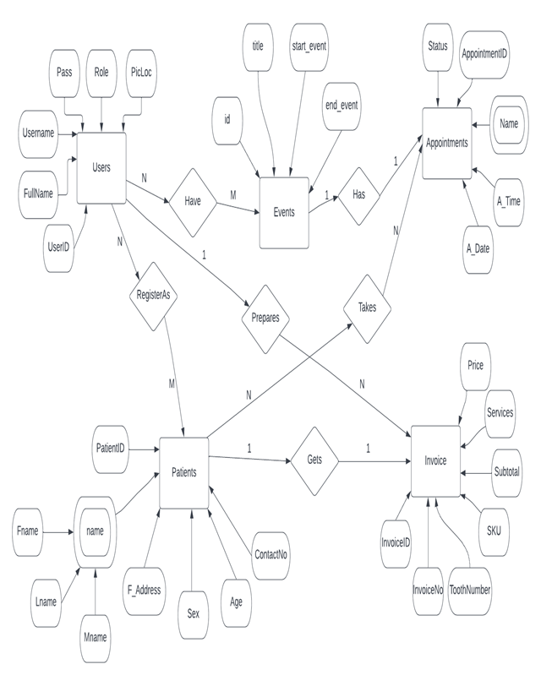

Figure :E R diagram for the database

**SCHEMA DIAGRAM**

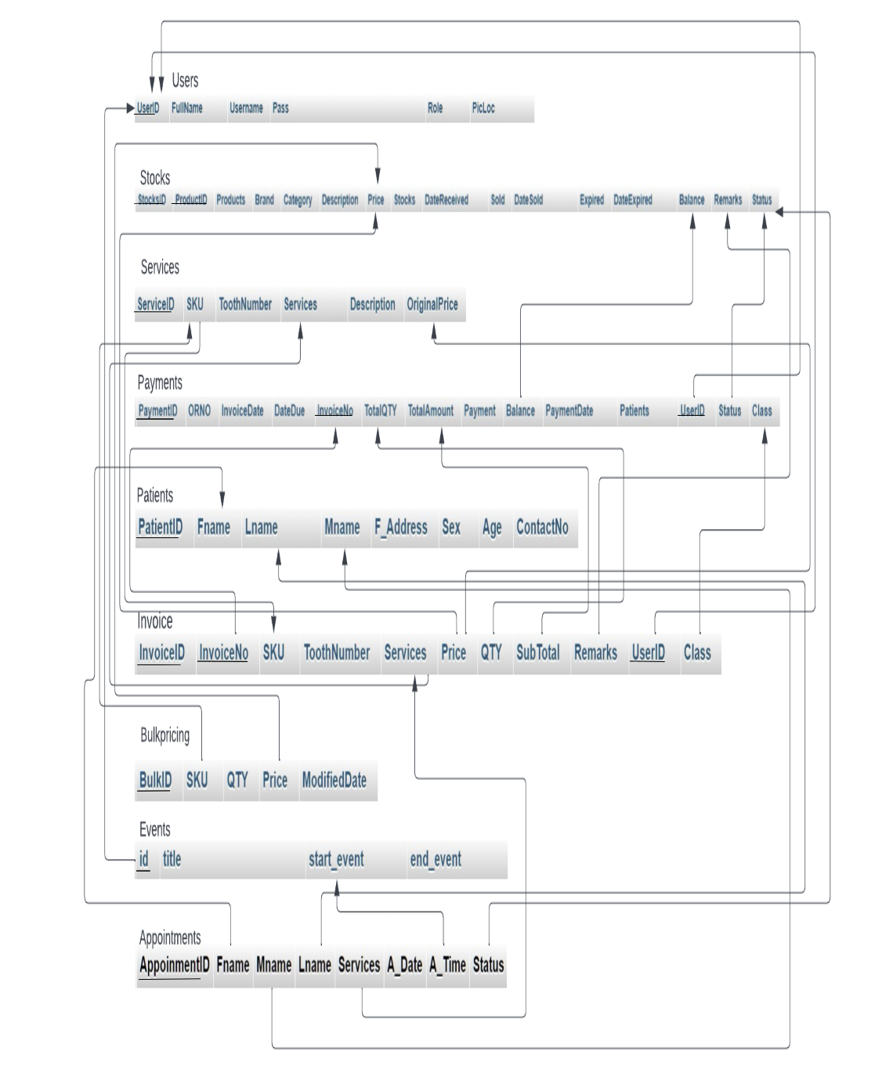

### Figure: Schema diagram

**LIST OF TABLES**

**1. Patient**

**2. Invoice**

**3. Service’s**

**4. Payment**

**5. Stocks**

**6. Currency**

# CHAPTER 3

# IMPLEMENTATION

#### Create table command & Insertion tables values:

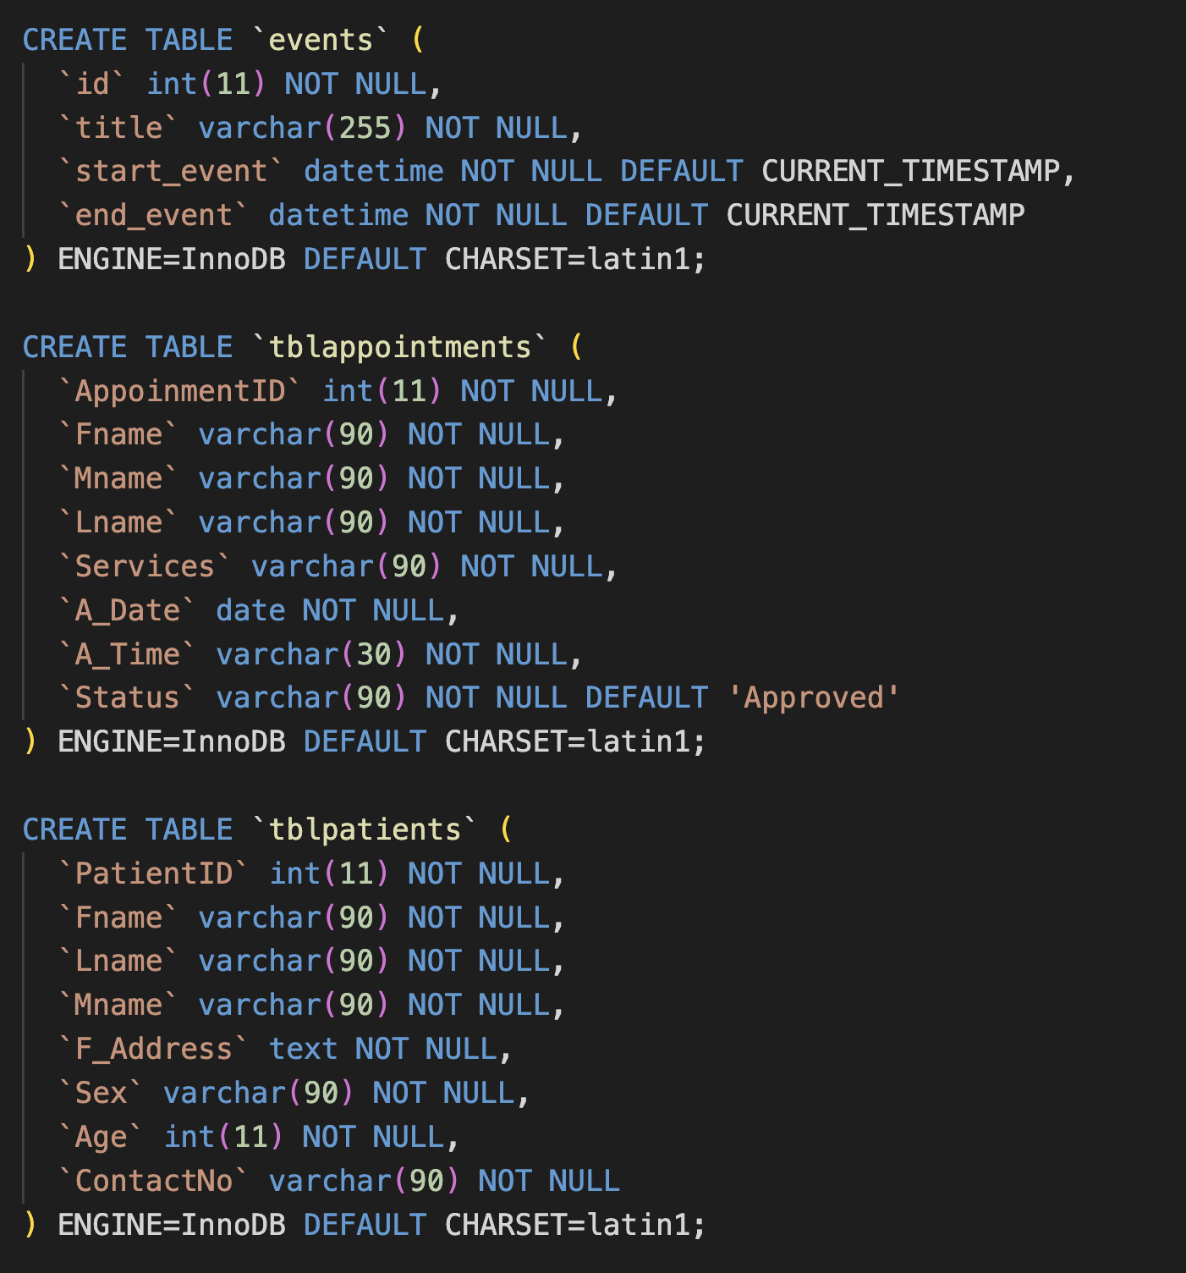

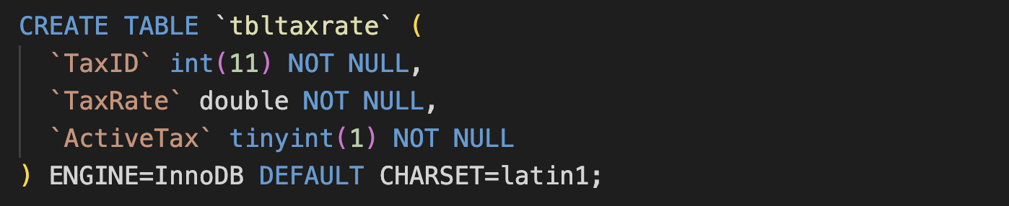

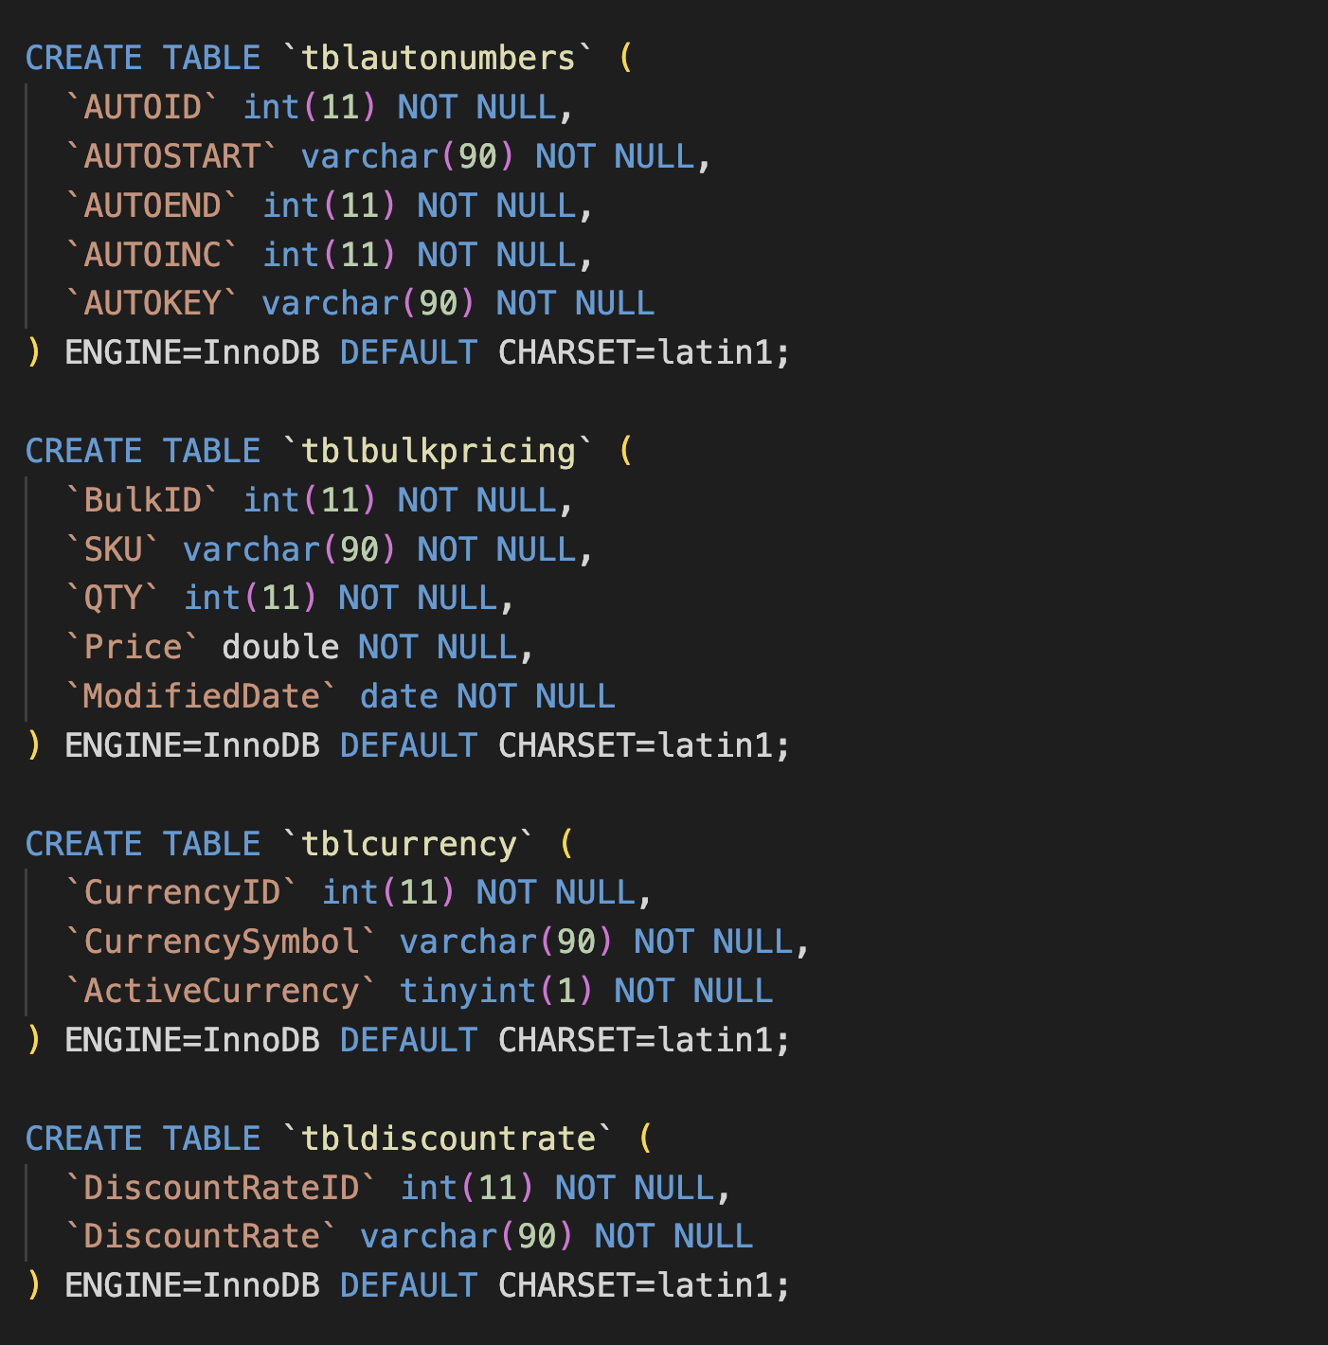

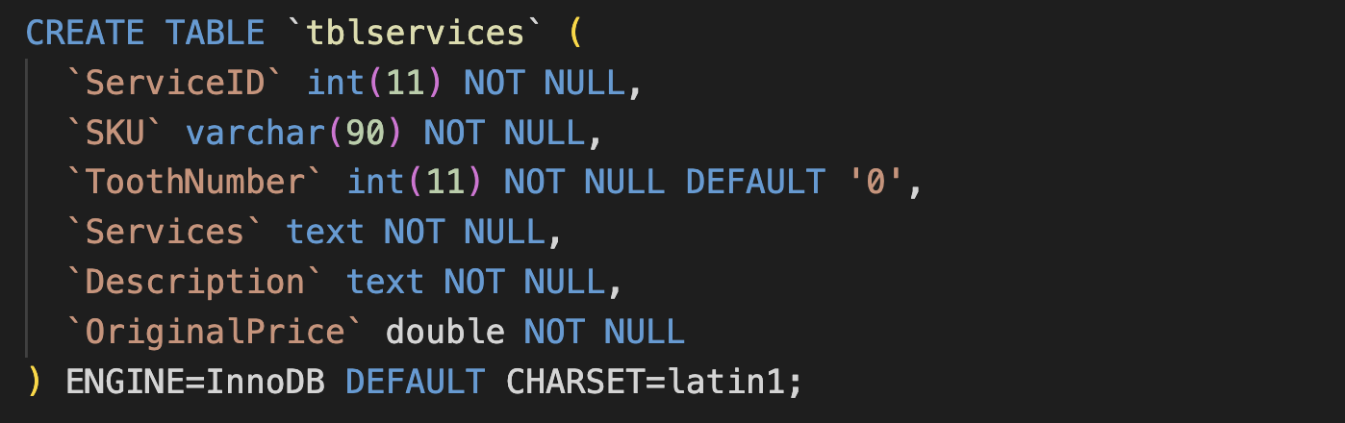

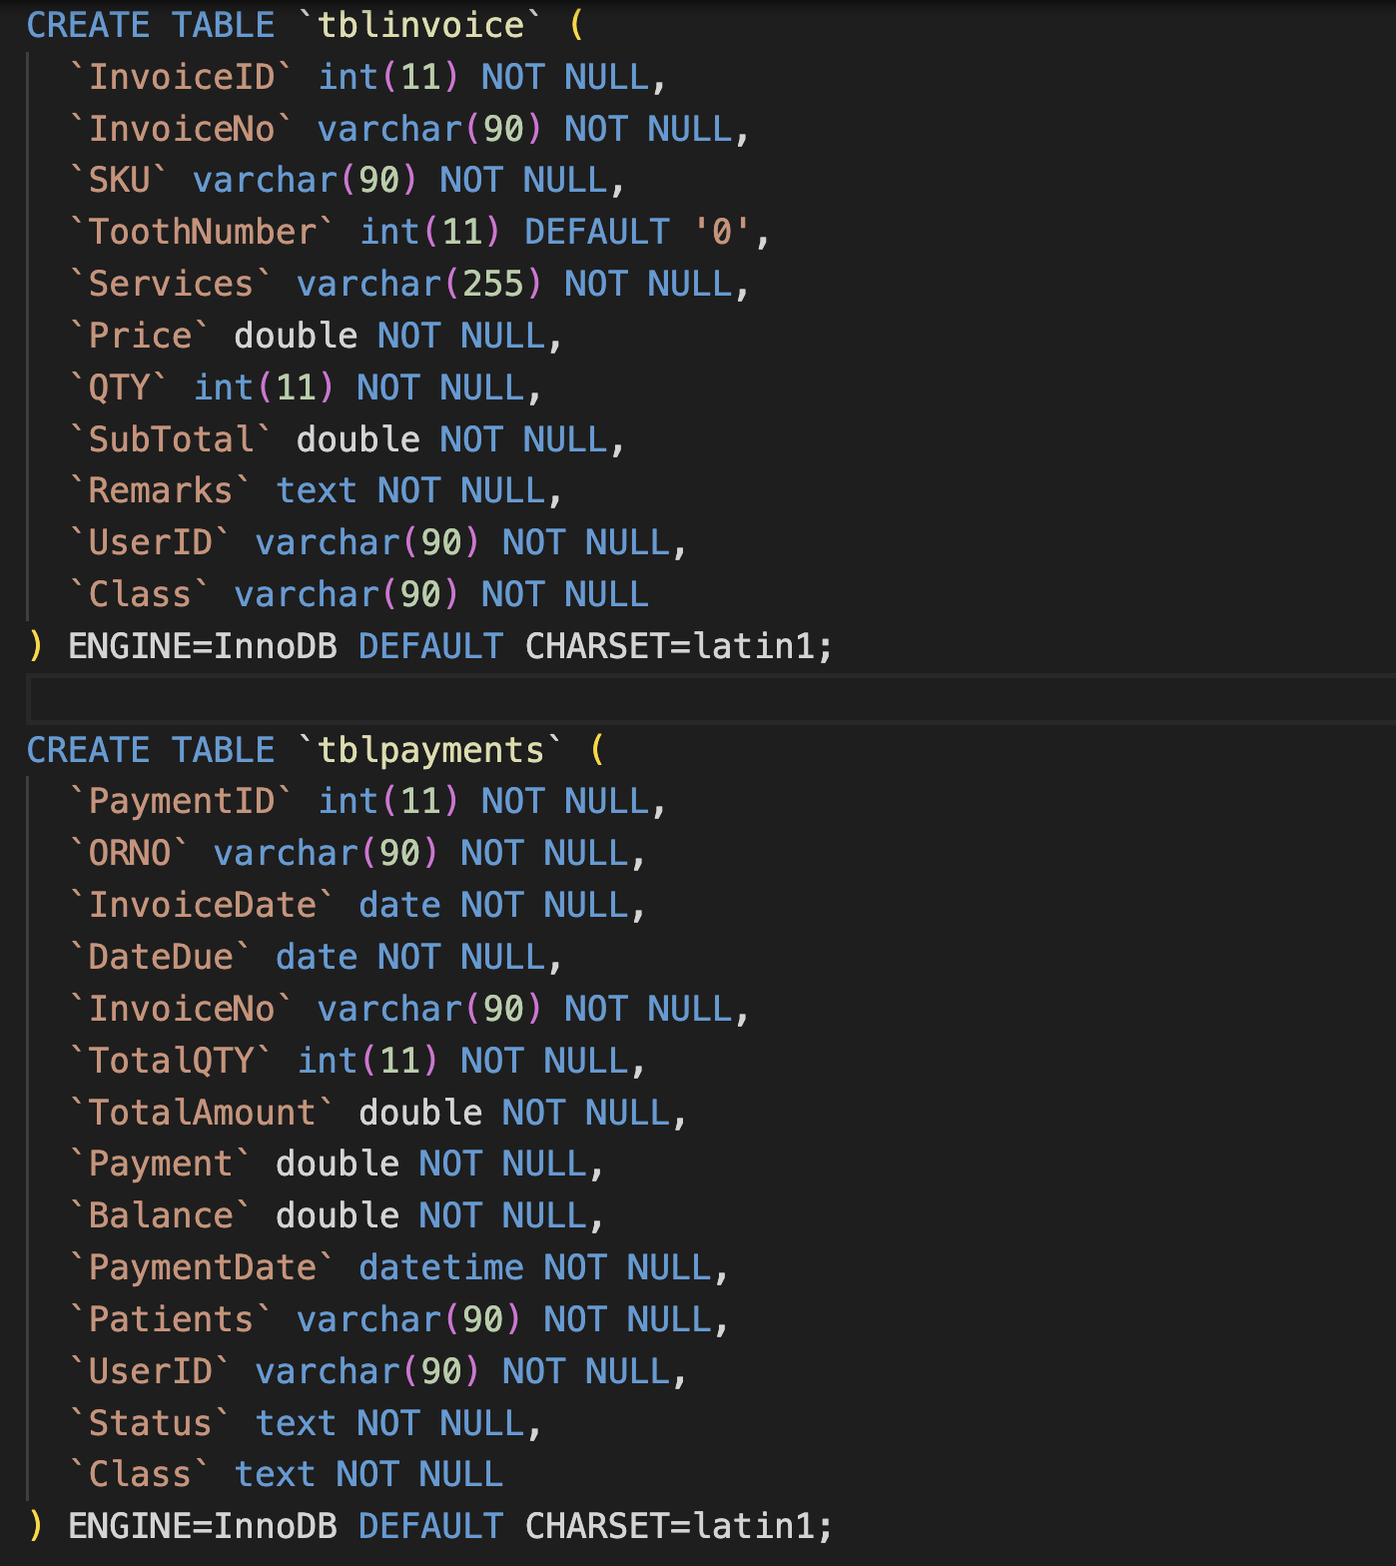

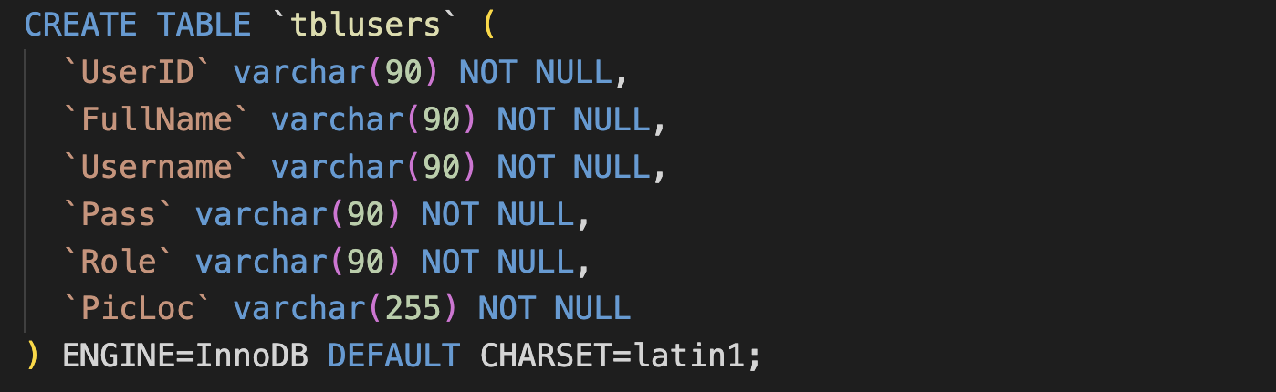

#### Snap Shots

**Patient Info**

PATIENT INFO table has a attributes patient_id,f_name ,I_ name,m_name ,email, address, sex, age, contact_no is used shown in table

STRUCTURE OF PATIENT INFO

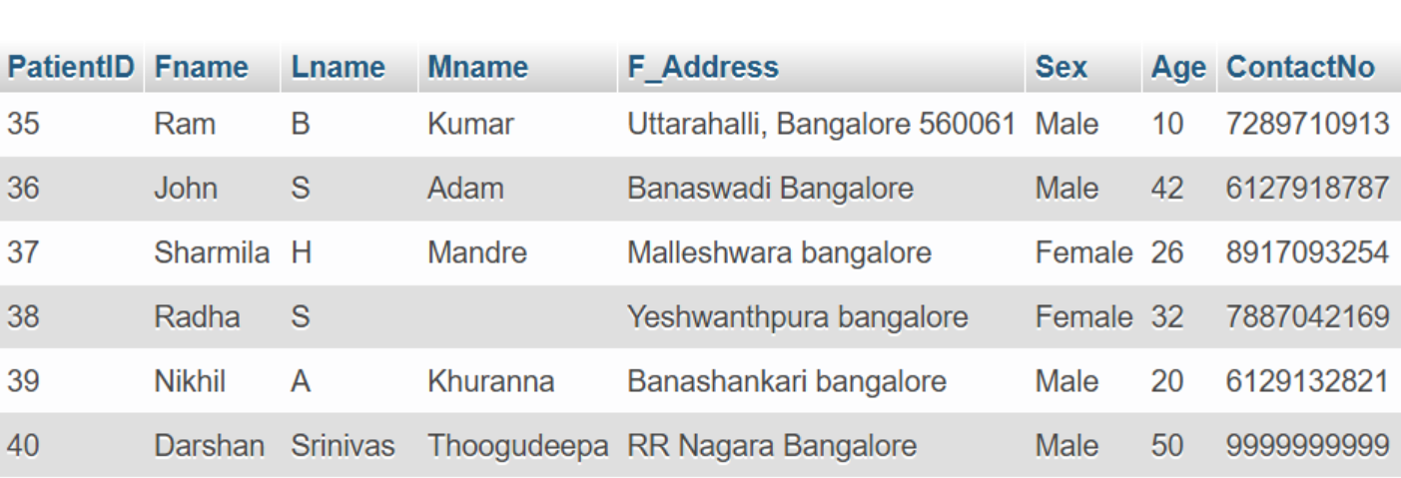

**Invoice List**

INVOICE LIST table has a attributes,Tooth number , services, price, quantity, sub_total, remarks,user_id and class, invoice_id,invoice number,is used as a primary key as shown in table

STRUCTURE OF TRAIN LIST

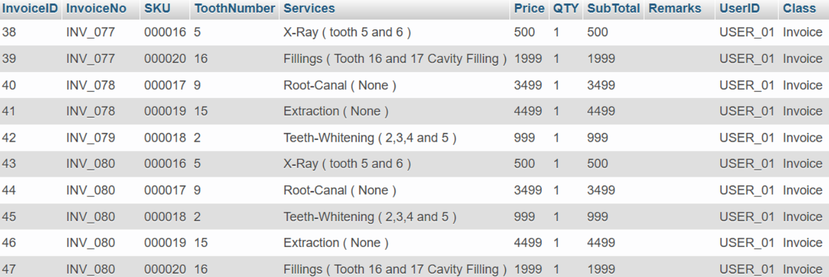

**Service’s**

SERVICE’S table has the attribute service_id,tooth_number,services,description,original_price is used shown in the table

STRUCTURE OF SEATS

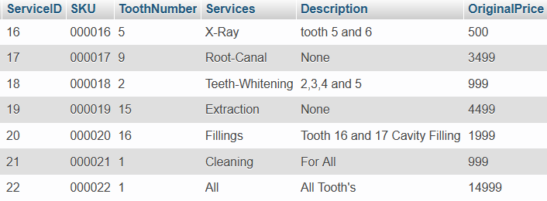

**Payment**

PAYMENT table has the attribute payment_id ,invoice_date,date_due,invoice_number,total_quantity,tot_amount,payment,balance,payment_date,patient_name,user_id,status_of_payment,class as shown in Table

STRUCTURE OF PAYMENT

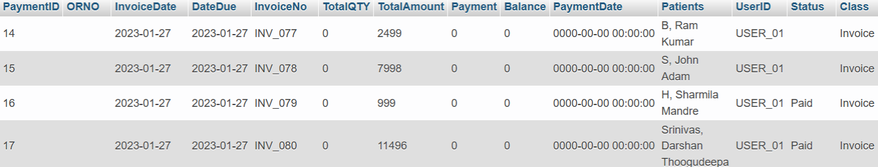

**Stocks**

STOCKS table has the attribute stock_id,product_id,products,brand,category,description,price,stocks,date_received,sold,date_sold,expired,date_expired,balance,remarks,status as shown in table

STRUCTURE OF STOCKS

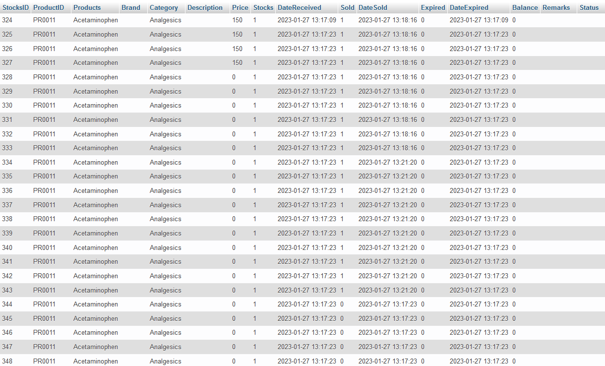

**Currency**

CURRENCY table has the attribute currency_id,currency_symbol and active_currency as shown in table

STRUCTURE OF CURRENCY

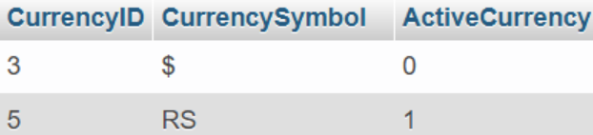

**CODE SNIPPETS**

**1. DATABASE CONNECTION**

The connect() / mysqli_connect() function opens a new connection to the MySQL server with the following syntax : mysqli_connect(host, username, password, dbname, port, socket).

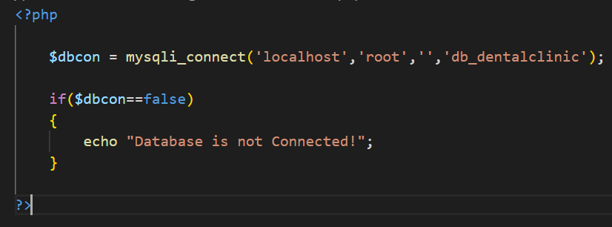

**2. INSERT QUERY**

This query is used to insert a booking.

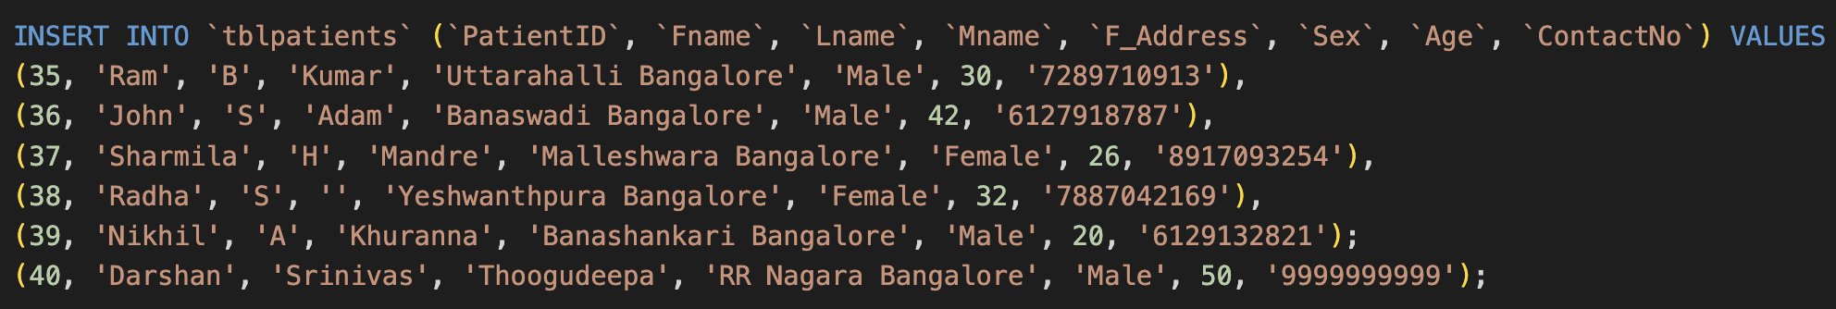

**3. SELECT QUERY**

In this query,all the details are fetched using SELECT* command.



**4. ALTER QUERY**

Here the alter query is called to update the patient of an already existing based on its name and and patient id respectively.



# CHAPTER 4

# RESULTS AND SNAPSHOTS

### HOME PAGE

### This is the first window when the application is executed.

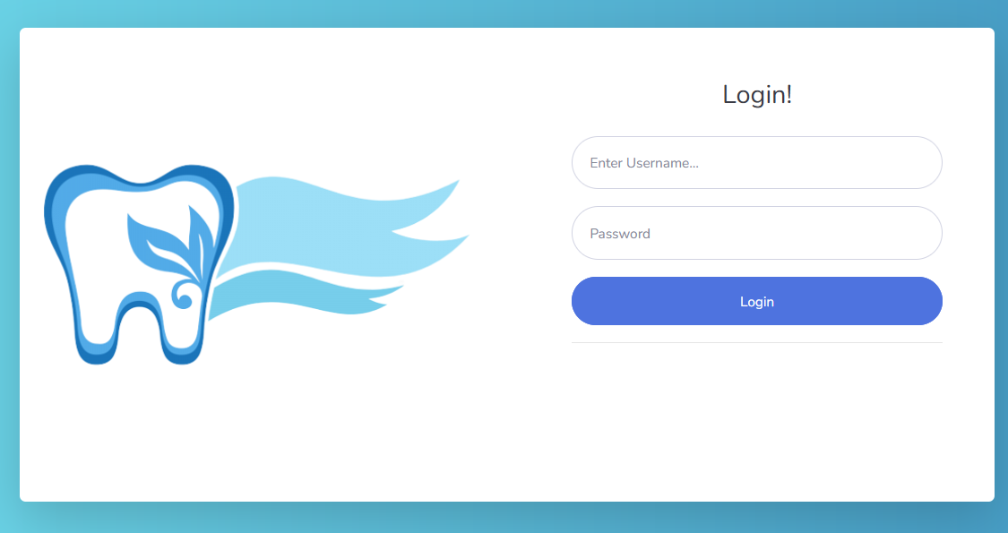

### ADMIN PAGE DASHBOARD

This page shows the booking or appointments on the calendar.

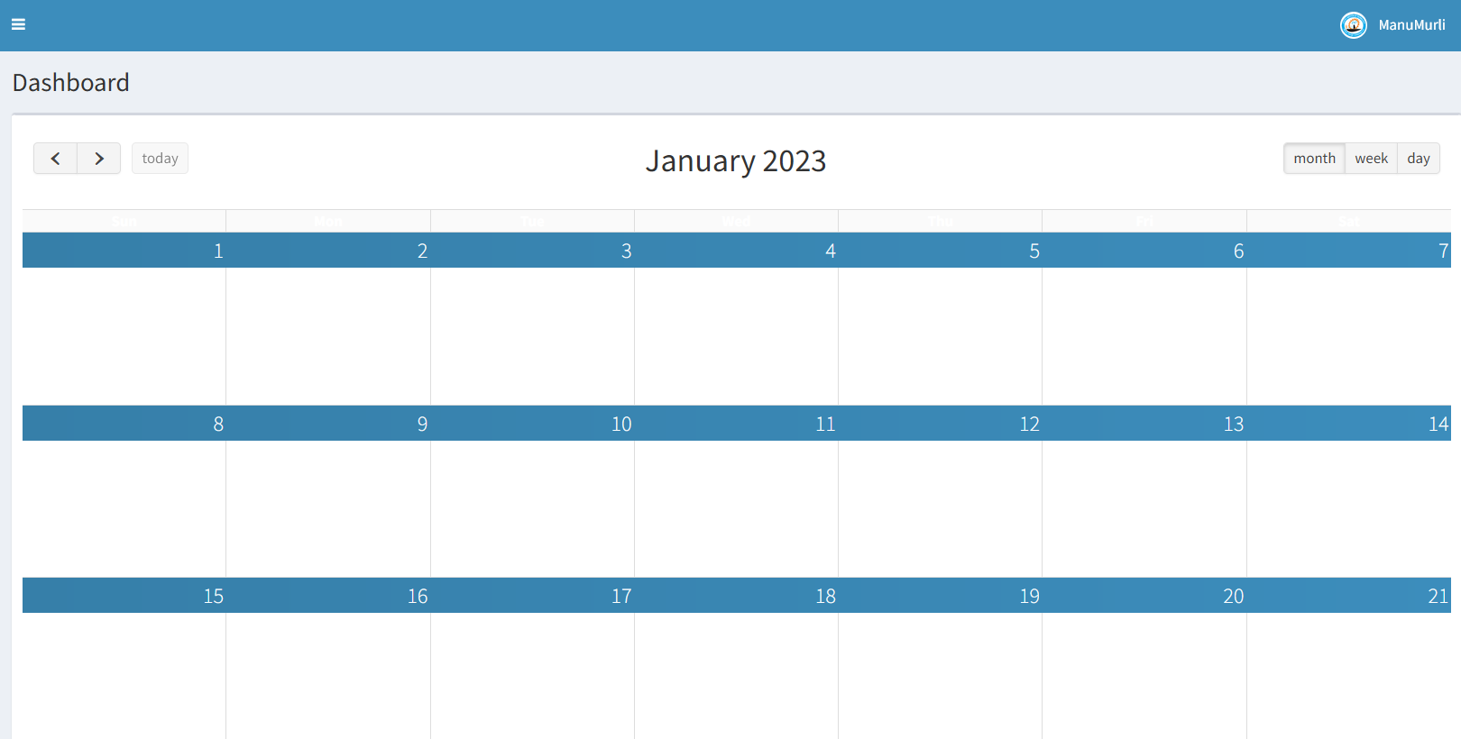

### ADMIN FIND PATIENT RECORD

This page allows admin to find Patient Record.

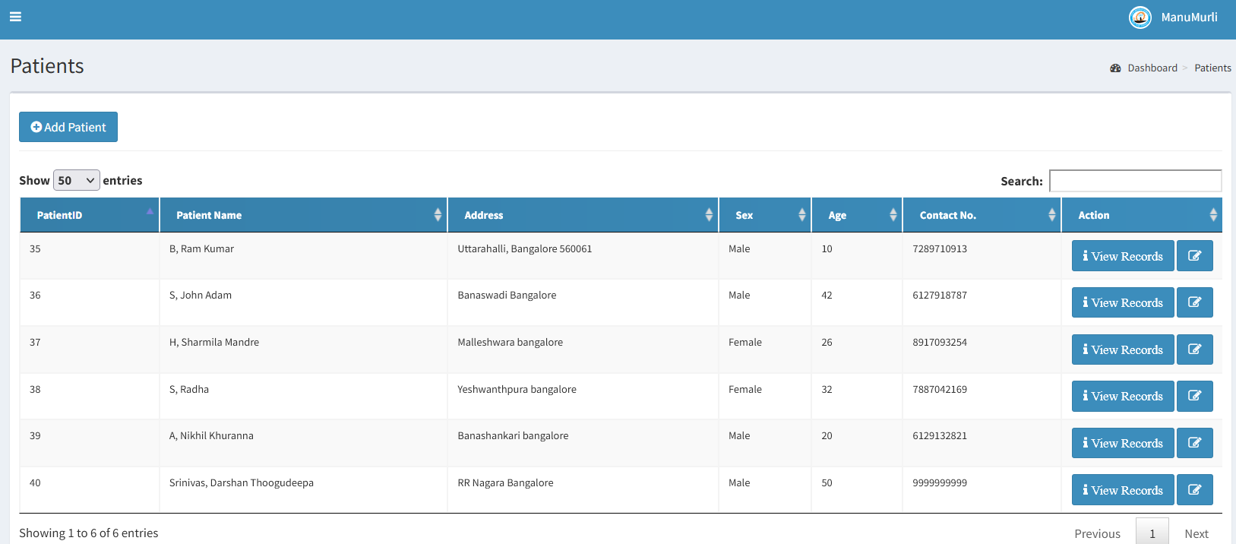

**SERVICES**

Services offered by the clinic.

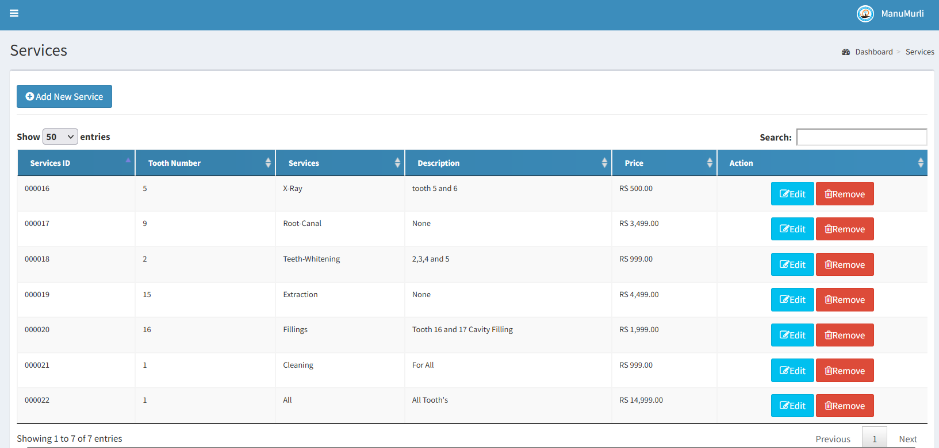

**MANAGE USERS**

This page provides access to add or modify and delete users.

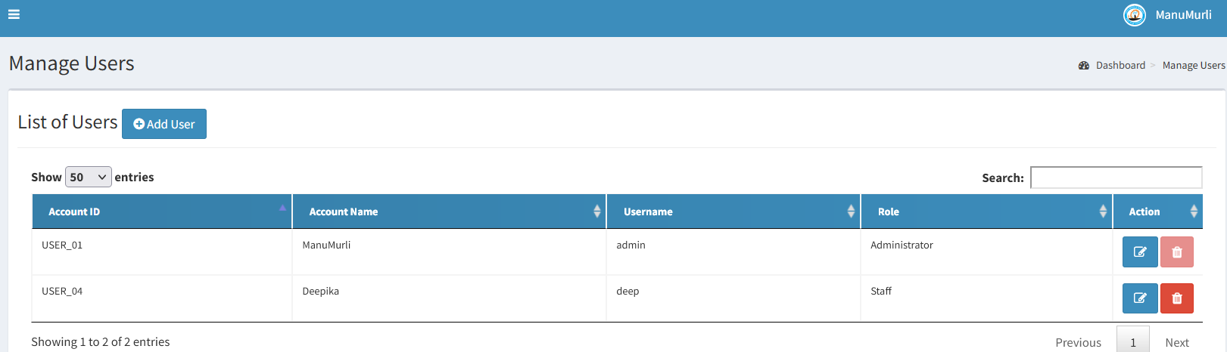

**CHAPTER 5**

**CONCLUSION & REFERENCES**

### CONCLUSION

In conclusion, a Dental Database Management System (DDMS) is a crucial tool for dental clinics to manage and organize patient data. It streamlines the process of storing, retrieving, and analyzing patient information, improving the overall efficiency and productivity of the clinic. The DDMS typically includes features such as patient registration, appointment scheduling, patient records management, billing and insurance management, and reporting tools.

It also helps to ensure the security and privacy of patient information by implementing strict security protocols and data encryption. Implementing a DDMS can help dental clinics to better manage and utilize their data, resulting in improved patient care, increased revenue, and a more efficient and productive clinic. Overall, a Dental Database Management System is a valuable asset for any dental clinic looking to improve their operations and patient care.

### REFERENCES

1. MySQL Database <https://www.mysql.com/downloads/>
2. PHP

<http://php.net/>

1. https://www.w3shools.com



